**Lenus**

[Working Title]

Exercise tracker and workout advisor

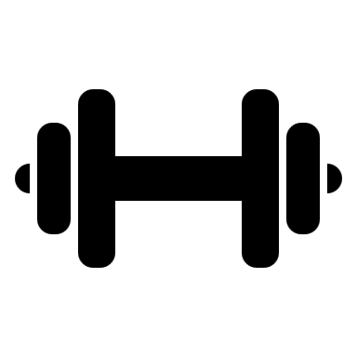

Design Proposal

Author: Davy Ryan

[G00236110@gmit.ie](mailto:G00236110@gmit.ie)

Date: 2018-10-09

Version: 1.0

# Contents

Design Proposal 3

Proposal Options 4

Stretch 1 4

Stretch 2 4

Stretch 3 4

Interface 5

Notes 6

# Design Proposal

The aim of this workout app is to help the user achieve their workout goal, such as a certain amount of push ups.

The type of trainings will be the military model and the sporadic model

For each the user will select a goal for themselves and then complete as much of the exercise as they can. The amount they could complete will be multiplied by 4, this is their starting amount to be completed over 8 sets.

Military Model:

This mode splits the workout over three days

Full Days: The user will complete all the sets in one go with at least a one minute rest between them.

Spread Days: The user will complete the sets over the course of the day, whenever the user has time.

Rest Days: there’s no workout on this day.

Sporadic Model:

This mode is for users that can’t or don’t want to commit to the military model.

The user will complete all sets in one go with at least a one minute rest between them.

After each workout the user will be asked to rate the difficulty and their future sets will be adjusted to better suit them.

Users can also bail out of workouts and select to have their sets adjusted or not because of this.

The app will also be able to track workouts without this mode.

# Proposal Options

The app will contain:

* Workout tracker
* Workout advisor
  + Military Model
  + Sporadic Model
* BMI calculator

Workouts contained in the app are:

* Push Ups
* Sit Ups
* Squats
* Lunges
* Deadlift
* Pull Ups
* Biceps Curl
* Triceps Extension
* Back Extension
* Plank

Depending on the time available additional features may be added.

## Stretch 1

Ability for the user to add additional workouts the app. Running and Marathon Trainer.

## Stretch 2

Workout recommendations based on users available equipment.

## Stretch 3

Targeted workouts based on user selected muscles. Nutritional info based on workouts and body type.

# Interface

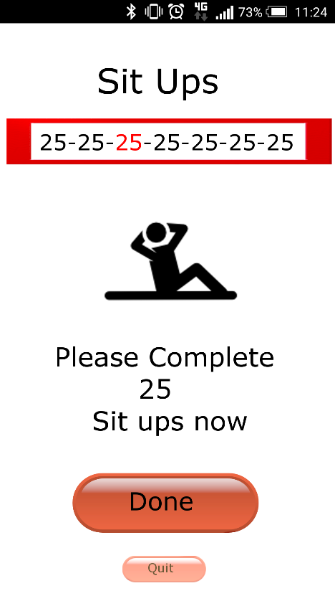The Workout page will show:

Workout

Number of sets and amount in them

Current set highlighted in red

Image of exercise

Instruction to complete set

Button for completion

Button to quit

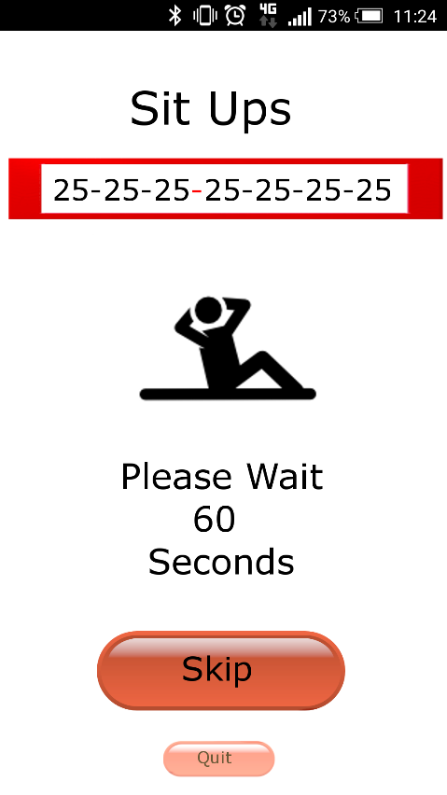

In-between sets the page will show:

Rest period highlighted in Red

Instruction to wait with countdown timer

Button to skip timer

# Notes

* The name Lenus comes from the Celtic god of Health and War
* Other possibilities are Búa ana Neartú